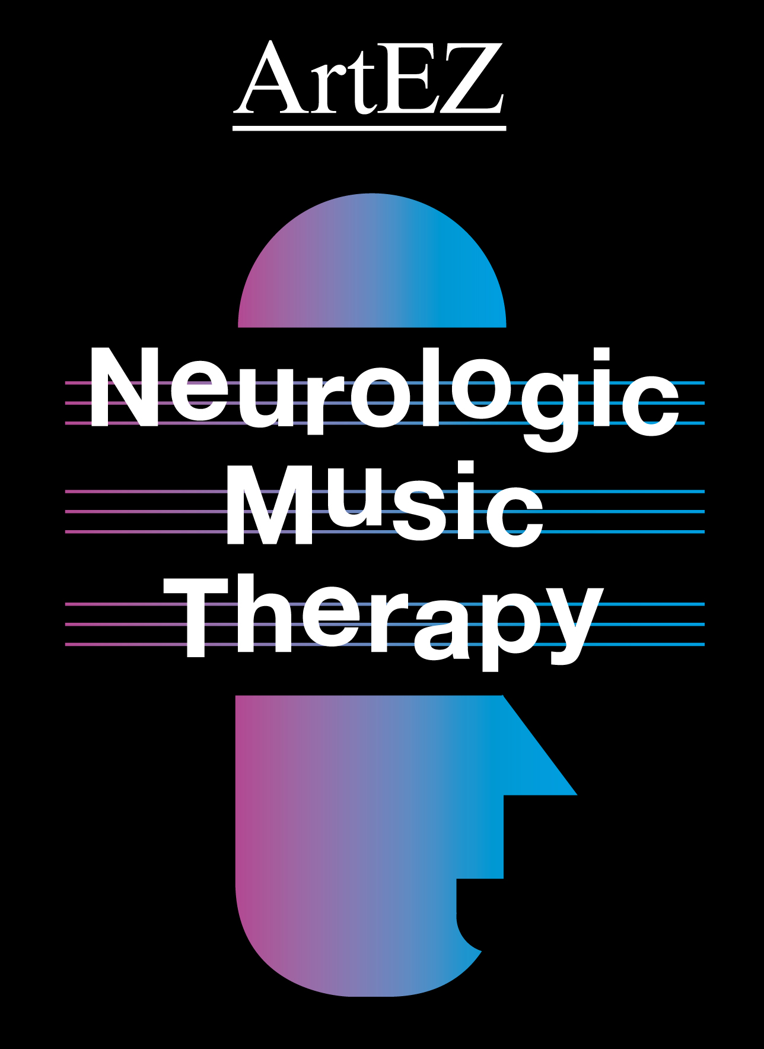 | Preparation for NMT-Fellowship

Each participant should prepare 3 video-examples of his own recent therapeutic work. The examples should demonstrate different NMT-Technics and cover at least 2 functional areas (for example Motor and Cognition). The video-examples are not allowed to be older than 1 year. The videos should be captured on laptop or Flash Drive (e.g USB-stick). The total length of the video-presentation should be between 5 and 7 minutes (not any longer!)
In the presentation the participant should display his use of the Transformational Design Model (TDM). This model optimizes the choices of treatment techniques applying the functional therapy goals. Of each case the diagnostics amnesias and functional goals should be clarified (see below).
The participant should demonstrate in his presentation a basic knowledge of the system and terms as applied for NMT-technics, together with its practical implementation.
Besides, the participant should display knowledge about recent research in his presentation and choices of clinical examples. He should be able to demonstrate recent ‘best-practice’ standards.
The participants should prepare clinical assessments to support the effectiveness of the NMT-technics.
During the meeting participants should answer questions about neuro-anatomy and neuro-pathology in connection with different neurological disorders.
Teachers, working in music therapy or creative therapy education, can use 3 video-excerpts of their actual teaching practice. A didactic-methodological transformation of the NMT-teaching should be demonstrated (explanation to the students, demonstration, facilitation towards the students, explaining feedback, etc.).
As a wrap-up of the training an anonymous voting will be applied of the presentations. Succeeding the NMT-Fellowship exams will be agreed upon with an absolute 70% majority vote. All participants have a vote. The course-leaders will have one vote, just as each participant. The verdict of the voting will be shared after the course. Each participant will hear within 2 weeks after completing the course whether he succeeded.
In case of not passing the Fellowship requirements, the Academy will ask the participant to send in additional or new 1 or more technics.
For the preparation of the NMT-Fellowship the following format (see next page) should be filled out and send to Dr. Corene Hurt-Thaut.
For a thorough preparation the following book is advised: Michael H. Thaut & Volkert Hoemberg (2014). Handbook of Neurologic Music Therapy, Oxford University Press.

Neurologic Music Therapy Fellowship Format

(Please fill out and e-mail this form to corenethaut@nmtacademy.co no later than May 17, 2019)

Be prepared to present the following information:

Technique: (make sure it is appropriate based on the diagnostics and goal of your client)

Diagnostics: (Remember to think about the diagnostics of your client during treatment selection)

Goal: (Make sure your treatment selection makes sense based on your goal)

Video Demonstration: (your video does not need to be long, but should clearly illustrate the effect of the technique)
*Your whole presentation should only last 5-7 minutes. The rest of the time will be spent discussing the video clips and receiving peer feedback.

Example:
Diagnostics/ Setting (brief): 54 yr. old, stroke, expressive aphasia, and inpatient rehab
Assessment Tool used (if applicable): Mississippi Aphasia Screening
Goal: Increase expressive language
Objective: Pt. will independently initiate 5 sentences
Technique: Melodic Intonation Therapy
Video Demonstration:

Technique #1
Diagnostics/ Setting (brief):
Assessment Tool used (if applicable):
Goal:
Objective:
Technique:

Technique #2
Diagnostics/ Setting (brief):
Assessment Tool used (if applicable):
Goal:
Objective:
Technique:

Technique #3
Diagnostics/ Setting (brief):
Assessment Tool used (if applicable):
Goal:
Objective:
Technique:

